Data Pipeline:
1. Data Source & Collection
- Source: Raw CSV file containing luxury housing data for Bangalore (developers, booking info, prices, configurations, amenities, etc.).
- Problem: The file was inconsistent — missing values, mixed formats, duplicates, and noise.
2. Data Cleaning & Preparation (Python)
- Tools Used: pandas, numpy, datetime, matplotlib, sqlalchemy.
- Key Cleaning Steps:
  - Removed duplicate and null records.
  - Standardized date formats and numerical columns (price, ticket_size, etc.).
  - Converted text columns (like developer_name, micro_market) to proper case.
  - Imputed missing amenity_score and booking_flag logically or with median values.
  - Derived new metrics:
    - Booking_Conversion_Rate = Booked_Count / Total_Enquiries
    - Total_Ticket_Sales = Avg_Ticket_Price × Booking_Count
    - Quarter_Year derived from booking date.
- Output: Clean dataset exported as Luxury_Housing_Sales_Analysis.csv.
3. Data Storage in PostgreSQL
- Database: PostgreSQL (chosen for scalability and Power BI integration).
- Loading Process:
  - Created SQL table schema using SQLAlchemy.
  - Loaded cleaned CSV into PostgreSQL using Python engine connection.
  - Verified data integrity with random sampling and summary stats.
4. Data Integration with Power BI
- Connection Type: Live connection to PostgreSQL (so dashboards refresh automatically).
- Data Modeling:
  - Defined relationships among Developer, MicroMarket, and Sales tables.
  - Created calculated columns and DAX measures such as:
    - Total Revenue = SUM(Total_Ticket_Sales)
    - Booking Success Rate = DIVIDE(Booked_Count, Total_Enquiries)
    - Avg Ticket Price = AVERAGE(Ticket_Price_Cr)

5. Dashboard Design in Power BI
Two interactive Power BI dashboards were created:
Dashboard 1: Market & Builder Overview -Contains 5 visuals:
- Market Trends (Line Chart) – Quarterly booking trend by micro-market.
- Builder Performance (Bar + Line Chart) – Total sales vs average ticket price.
- Amenity Impact (Scatter Plot) – Relationship between amenities and bookings.
- Booking Conversion (Donut Chart) – Booking % by configuration type.
- Configuration Demand (Stacked Column) – Booked vs not booked by micro-market.

Dashboard 2: Channel & Buyer Insights-Contains another 5 visuals:
6. Sales Channel Efficiency (Stacked Chart) – Booking status by sales channel.
7. Quarterly Builder Contribution (Matrix) – Quarterly revenue contribution by builder.
8. Possession Status Analysis (Clustered Chart) – Buyer type vs possession stage.
9. Geographical Insights (Map) – Micro-market project distribution in Bangalore.
10. Top Performers (KPI/Table) – Top 5 builders by revenue & booking success.
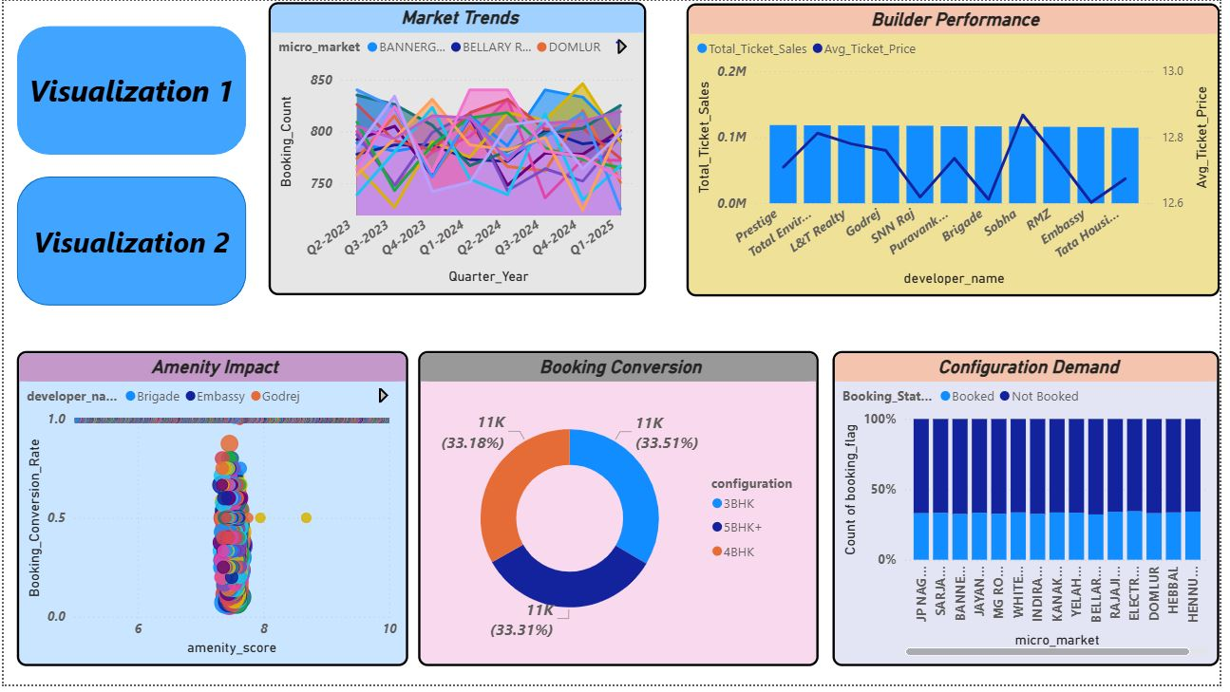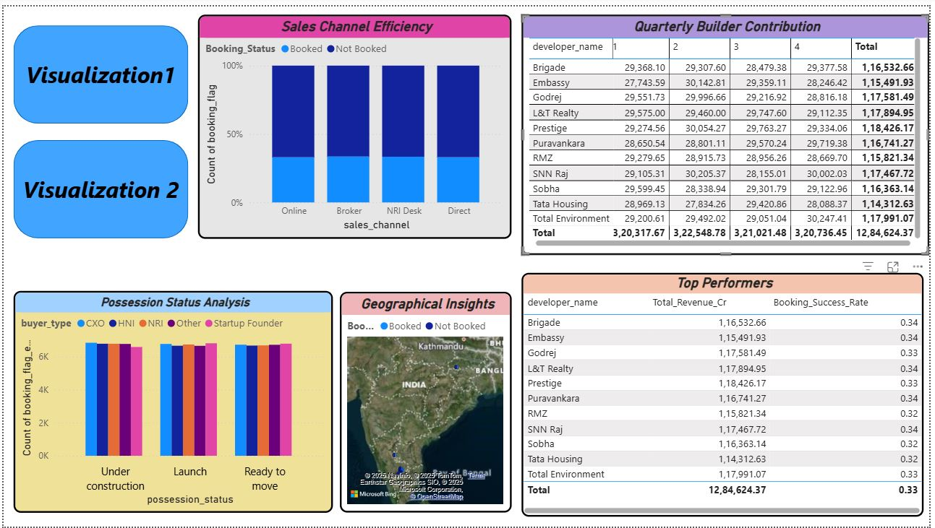

INSIGHTS
Sno | Category | Visualization | Key Findings | Implications / Recommendations
1 | Market Trends | Quarterly bookings by micro-market | Demand fluctuates but Bellary Road & Domlur show consistent upward trends, while some like Bannergatta remain volatile. | Focus marketing & premium project launches in stable upward micro-markets.
2 | Builder Performance | Total sales vs avg ticket price | Prestige, L&T Realty, Sobha, Brigade lead in both revenue and high average ticket size. | Builders maintaining both volume & price strength should be given priority for partnerships.
3 | Amenity Impact | Amenity score vs conversion rate | Moderate positive correlation — higher amenity score improves booking rates, especially for developers like Embassy & Godrej. | Invest in lifestyle amenities (clubhouse, smart home tech) to drive higher conversion.
4 | Booking Conversion | Booking rate by configuration | 3BHK, 4BHK, and 5BHK+ show almost equal conversion share (~33% each). | Balanced market; can bundle smart pricing or interior packages to drive marginal preference.
5 | Configuration Demand | Booking status by micro-market | Micro-markets like JP Nagar, Sarjapur, Whitefield show stronger “Booked” ratios. | Reallocate sales focus & event campaigns to high-demand zones.

Sno | Category | Visualization | Key Findings | Implications / Recommendations
6 | Sales Channel Efficiency | Channel-wise booking success | Broker and Direct channels dominate bookings; NRI Desk underperforms. | Strengthen digital marketing and NRI-focused lead conversion initiatives.
7 | Quarterly Builder Contribution | Builder revenue per quarter | Consistent top contributors: Brigade, Embassy, L&T Realty, Sobha. | Develop co-branding with these builders; offer joint promotional campaigns.
8 | Possession Status Analysis | Buyer type vs possession | Most HNI and CXO buyers prefer under-construction properties; NRIs prefer ready-to-move. | Offer customized communication—construction updates for HNI, virtual tours for NRIs.
9 | Geographical Insights | Map of project distribution | Luxury projects are concentrated in central and eastern Bangalore (Whitefield, Domlur, Bellary Rd). | Expand into untapped western zones with rising infrastructure growth.
10 | Top Performers | KPI of top 5 builders | Top 5 builders contribute over 60% of total revenue; avg success rate ~0.33–0.34. | Focus partnership ecosystem around these builders; track mid-tier growth opportunities.

BUSINESS RECOMMENDATIONS
- Enhance Amenity Offerings
- Insight Reference:
From the Amenity Impact scatter plot (Booking_Conversion_Rate vs Amenity_Score), projects with higher amenity scores — especially those developed by Embassy, Godrej, and Brigade — consistently achieved above-average booking success rates.
This indicates that amenity-rich environments drive emotional and aspirational value for luxury buyers.
- Strategic Actions:
Expand high-impact amenities: Include EV charging stations, rooftop infinity pools, digital home automation, wellness centers, and pet-friendly zones.
Focus on perceived luxury: Developers should emphasize experiential amenities such as concierge services, private clubhouses, and smart community apps in marketing.
Use Power BI to monitor ROI: Track how new amenity additions impact future booking conversion in subsequent quarters through the live dashboard.
- Expected Outcome:
A 5–10% improvement in conversion rates and stronger premium perception, especially in high-income buyer segments (HNI, CXO).

- Micro-Market Prioritization
- Insight Reference:
From the Market Trends line chart, Bellary Road, Domlur, and Whitefield show steady quarter-over-quarter growth in booking counts, while Bannergatta Road and Hebbal show high volatility.
- Strategic Actions:
Reallocate marketing budgets toward top-performing micro-markets with consistent upward booking trends.
Cluster-based campaign planning: Launch location-specific digital campaigns highlighting nearby landmarks, schools, and corporate zones.
Saturation monitoring: Use Power BI’s trend lines to detect when a micro-market reaches maturity and begin identifying the next emerging zone.
- Expected Outcome:
Improved marketing efficiency (ROI) and higher absorption rates in high-demand zones.

- Channel Optimization
- Insight Reference:
The Sales Channel Efficiency visualization shows Broker and Direct channels contributing the majority of successful bookings, while NRI Desk conversions are comparatively lower.
- Strategic Actions:
Enhance NRI sales experience: Implement seamless digital booking and virtual site visits to improve the NRI Desk’s conversion ratio.
Leverage data-driven advertising: Use lead scoring and predictive analytics to identify high-probability prospects from online channels.
Broker empowerment: Offer brokers real-time Power BI snapshots of inventory, pricing, and lead progress to speed up deals.
- Expected Outcome:
Boost in overall conversion efficiency by 8–12% and reduction in lead-to-booking time across all channels.

- Builder Partnerships
- Insight Reference:
The Builder Performance and Top Performers visuals show that Prestige, L&T Realty, Sobha, Brigade, Embassy collectively contribute over 60% of total ticket sales and maintain booking success rates around 33–34%.
- Strategic Actions:
Develop exclusive builder tie-ups: Launch co-branded campaigns or priority lead-sharing agreements with top developers.
Cross-promote successful builder projects: Feature their best-performing projects on high-visibility Power BI dashboards for leadership review.
Support mid-tier builders: Offer strategic consulting to underperforming builders to improve amenity quality and pricing structures.
- Expected Outcome:
Sustained revenue stability from established builders and capacity growth from developing partners, ensuring long-term ecosystem balance.

- Customer Segmentation
- Insight Reference:
From the Possession Status Analysis, HNI and CXO buyers predominantly book under-construction projects, while NRIs lean toward ready-to-move properties.
- Strategic Actions:
Personalized marketing campaigns:
  - HNI/CXO segment: Offer early-bird pre-launch investment options, priority upgrades, and financing plans.
  - NRI segment: Promote completed projects with hassle-free documentation and property management services.
Buyer-type dashboards: Use Power BI filters to track conversion rates segmented by buyer category and possession type.
Behavior-based follow-up automation: Integrate CRM systems to target specific buyer personas.
- Expected Outcome:
Enhanced customer satisfaction, higher lead retention, and optimized inventory turnover.

- Pricing Strategy
- Insight Reference:
The Builder Performance visual indicates average ticket prices between ₹12.6–₹12.8 Cr, suggesting a price plateau. However, certain builders sustain strong sales at the higher end of the spectrum.
- Strategic Actions:
Introduce value-based pricing tiers: Offer modular pricing — e.g., “Luxury Essentials” vs “Luxury Premium.”
Incorporate flexible payment plans: Early bird offers or possession-linked plans to reduce buyer hesitation.
Monitor price elasticity: Use Power BI to visualize the relationship between pricing changes and booking conversions over time.
- Expected Outcome:
Improved price competitiveness without diluting brand value; ability to maintain average ticket size while expanding buyer base.

- Expansion Strategy
- Insight Reference:
Geographical Insights reveal project clustering in Central and Eastern Bangalore (Whitefield, Domlur, Bellary Road). Western corridors show fewer but growing projects.
- Strategic Actions:
Market feasibility studies in western Bangalore — areas like Mysore Road, Nagarbhavi, and Peenya — for new luxury project launches.
Infrastructure-driven expansion: Target micro-markets benefiting from upcoming metro connectivity and expressways.
Diversify portfolio: Introduce hybrid projects (luxury + sustainable housing) to attract new demographics.
- Expected Outcome:
Geographic diversification leading to 10–15% incremental market share growth over 2 years.

- Quarterly Monitoring Framework
- Insight Reference:
The Quarterly Builder Contribution matrix and Market Trends line chart show strong quarterly variations, highlighting the importance of continuous performance tracking.
- Strategic Actions:
Maintain live PostgreSQL–Power BI integration to monitor real-time revenue and booking data.
Create quarterly review dashboards for builder contributions, channel efficiency, and amenity ROI.
Set dynamic KPIs: Automate alerts for underperforming builders or regions through Power BI’s data-driven triggers.
- Expected Outcome:
Improved data agility, faster decision-making, and early risk detection — ensuring responsive strategy adjustments per quarter.

